**Homework 5**

1. **Academic integrity**

I have read and understood the course academic integrity policy.

1. **CRC** – Consider the 5-bit generator G=10011, and suppose that D has the value 1010101010. What is the value of R? Repeat the problem when D has the value 1001000101. Show all your work.

Since G is 5-bit pattern generator, the r is 4.

When D is 1010101010:

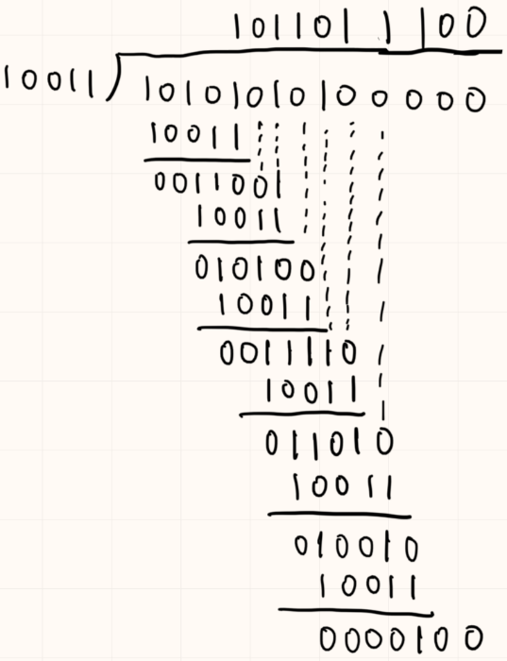

The R is 100.

When D is 1001000101:

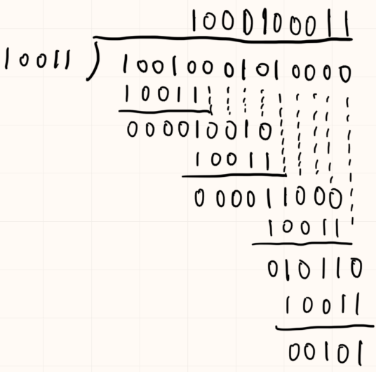

The R is 101.

1. **Polling** – Consider a broadcast channel with *N* nodes and a transmission rate of *R* bps. Suppose the broadcast channel uses polling (with an additional polling node) for multiple access. Suppose the amount of time from when a node completes transmission until the subsequent node is permitted to transmit (that is, the polling delay) is *dpoll*. Suppose that within a polling round, a given node is allowed to transmit at most *Q* bits. Further suppose node 1, initially with no bits to send, receives *Q* bits to send. What is the maximum time from when node 1 receives the bits until it can begin to send them?

When the node form a ring, the sum of the polling delay is the longest.

The whole transmission time = *N * Q/R*.

The whole polling delay = *N * dpoll*.

So the maximum time = *N * (Q/R + dpoll)*.

1. **CSMA/CD** – In CSMA/CD, after the fourth collision, what is the probability that the node chooses K = 5? The result K = 5 corresponds to a delay of how many microseconds on a 10 Mbps Ethernet?

At this situation, the set has 24 elements = {0, 1, 2, …, 24 - 1}, the probability is 1/24 = 1/16.

Since it’s a 10 Mbps Ethernet, its 512-bits-time is 51.2 ms, and the delay is 5 * 51.2 ms = 256 ms.

1. **Self-learning switch** – Consider an Ethernet LAN consisting of N nodes interconnected with a switch. Suppose the switch’s forwarding table is initially empty. Suppose node A wants to perform a TCP three-way handshake with node B, where both nodes are on the LAN. Assuming this is the only traffic on the network, and there are no packet errors or loss, how many frames will be transmitted in the process of establishing the TCP connection? Assume node A knows the IP address of node B, and ARP tables have all the necessary mappings.

In the beginning, A sends 1 frame to the forwarding table, but it’s empty, so switch writes a record of MAC A, and then it sends same frames to all other nodes to find B, which needs to send N – 2 frames, so the first handshake needs N – 1 frames. When B responds, it finds A’s record, so it sends 1 frame and the switch writes a record of MAC B. In the last handshake, the forwarding table already has B’s record, so A only needs to send 1 frame. Totally, it needs N + 1 frames.

1. **Multiple access protocols: voice-over-IP and data.** – In this chapter, we studied a number of multiple access protocols, including TDMA, CSMA, slotted Aloha, and token passing.
2. Suppose you were charged with putting together a large LAN to support IP telephony (only) and that multiple users may want to carry on a phone call at the same time. Recall that IP telephony digitizes and packetizes voice at a constant bit rate when a user is making an IP phone call. How well suited are these four protocols for this scenario? Provide a brief (one sentence) explanation of each answer.

TDMA: It’s suitable, since its uniform time interval ensures stable calls from multiple nodes.

CSMA: It’s not suitable, since the carrier sensing and collision detection affect calls quality seriously.

slotted Aloha: It’s not suitable, since simultaneous calls have a high probability of frame collision.

token passing: It can be used but not so much suitable, since a passing error can make all transmissions unavailable.

1. Now suppose you were charged with putting together a LAN to support the occasional exchange of data between nodes (in this part of the question, there is no voice traffic). That is, any individual node does not have data to send very often. How well suited are these four protocols for this scenario? Provide a brief (one sentence) explanation of each answer.

TDMA: It’s not suitable, since it will waste a lot of bandwidth.

CSMA: It’s suitable, since the occasional transmission makes sensing very efficient.

slotted Aloha: It’s suitable, since it fits well with both occasionality and collision control.

token passing: It can be used but not so nuch suitable, since there is probably a large time interval in occasional token passing, thus raise error probability.

1. Now suppose the LAN must support both voice and data and you must choose one of these multiple access strategies in order to support both applications on the same network, with the understanding that voice calls are more important than data. How would voice and data be sent in this scenario? That is, which access protocol would you use, or adapt/modify, and why?

In summary of the above 2 questions, I choose to use token passing. Because this method works in both two separate a) and b) cases. Also according to the question, the voice call is more important than data, so if I let nodes to set a higher using level to the call frames, then the token will be delivered to the call frames more frequently and it satisfy the condition.